LNPA Working Group Meeting Schedule
March 15-16, 2011
Hosted by Comcast
5800 S. Quebec St.
Greenwood Village, CO 80111.

Agenda

LNPA Working Group (LNPA WG)

Tuesday, March 15, 2011 9:00 AM – 5:00 PM (Mountain Time Zone)

Conference Bridge – 888-412-7808 PIN 23272#

9:00 a.m. - Introductions and Agenda Review – All

- Approve January 11-12, 2011 and February 8, 2011 Minutes – All
(NOTE: The February 8, 2011 LNPA WG call minutes will be reviewed and approved at the March 2011 LNPA WG meeting. The February 8, 2011 APT call minutes will be reviewed and approved on the April 12, 2011 APT call.)

- FCC Order 09-41 Implementation Discussion – All

- Action Item 091410-01: Neustar will issue an alert over the Cross-Regional distribution advising Service Providers to be prepared for the January 30, 2011 Sunday maintenance window to update their Medium Timer Indicator profile if they are implementing one business day porting on February 2, 2011. The alert is to be sent out now and then every 30 days leading up to the January 30, 2011 maintenance window.

- Action Item 110910-04: Service Providers are to send their planned implementation date of one business day porting (FCC Order 09-41) and associated SPID(s) to the LNPA WG Co-Chairs (gary.m.sacra@verizon.com, paula.jordan@t-mobile.com, and lpeterman@onecommunications.com) by January, 15, 2011.

- Action Item 011111-02: Neustar will update the list of Service Providers who have been granted regulatory waivers from porting and send the list out over the LNPA WG e-mail distribution list and upload it to the LNPA WG’s website.

- Action Item 020811-01: Neustar will investigate the possibility of excluding LSMS-only SPIDs from the Medium Timer Indicator (MTI) support list on the secure NPAC website.

- Action Item 020811-02: Neustar will investigate the possibility of including the Service Provider name associated with each SPID on the Medium Timer Indicator (MTI) support list on the secure NPAC website.
LNPA Working Group Meeting Schedule
March 15-16, 2011
Hosted by Comcast
5800 S. Quebec St.
Greenwood Village, CO 80111.

Agenda

LNPA Working Group (LNPA WG) - CONTINUED

Tuesday, March 15, 2011 9:00 AM – 5:00 PM (Mountain Time Zone)

Conference Bridge – 888-412-7808 PIN 23272#

- Discussion of FCC 09-41 Non-Compliance – Paula Jordan

- Lessons Learned – All

Action Item 011111-08: Gary Sacra, LNPA WG Co-Chair, will develop a document of potential items that could be included in an FCC 09-41 (one-day porting) Lessons Learned document for inclusion in the March 2011 LNPA WG meeting agenda and ongoing discussion.



11:30 – 1:00 - Lunch

1:00 p.m. - Continuation of Morning Agenda (IF NECESSARY) – All

- Addition and Prioritization of Future LNPA WG Agenda Items – All



LNPA Working Group Meeting Schedule
March 15-16, 2011
Hosted by Comcast
5800 S. Quebec St.
Greenwood Village, CO 80111.

Agenda

LNPA Working Group (LNPA WG) - CONTINUED

Tuesday, March 15, 2011 9:00 AM – 5:00 PM (Mountain Time Zone)

Conference Bridge – 888-412-7808 PIN 23272#

- Review & Update of LNPA WG Best Practices Document – All

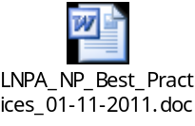

Action Item 011111-09: Gary Sacra, LNPA WG Co-Chair, will make the following revisions to the LNPA NP Best Practices document agreed to at the January 2011 LNPA WG meeting. These will be further discussed as part of the LNPA WG’s ongoing update to the Best Practices document.
- Explain at the top of the table that these BPs have been approved by industry participants of the LNPA WG and in some cases endorsed by the NANC and/or adopted by the FCC. Highlight via an asterisk those that have been endorsed/adopted and put in a footnote.
- Do a word search and capitalize “service provider(s).”
- Change references of “NeuStar” to “Neustar.”
- Embed the LNPA WG N-1 Interpretation v5 document in BP 4.
- Add reference to NANC Flow A Figure 9 Step 8 and Flow AA Figure 10 Step 8 to BP 9.
- Distribute latest draft BP document with proposed revisions to date for discussion at the March 2011 LNPA WG meeting.

Action Item 011111-03: Neustar will draft proposed text to update Best Practice 11 – Neustar Application Process.

Action Item 011111-04: Renee Dillon, AT&T Mobility, will draft proposed text for updating Best Practice 22 for review at the March 2011 LNPA WG meeting.

5:00 p.m. - Adjourn

LNPA Working Group Meeting Schedule
March 15-16, 2011
Hosted by Comcast
5800 S. Quebec St.
Greenwood Village, CO 80111.

Agenda

LNPA Working Group (LNPA WG)

Wednesday, March 16, 2011 9:00 AM – 5:00 PM (Mountain Time Zone)

Conference Bridge – 888-412-7808 PIN 23272#

9:00 a.m. - Issues from Other Industry Groups:
- OBF Wireless Ordering Task Force – Deb Tucker
- OBF Local Ordering Task Force – Linda Peterman
- INC Update – Dave Garner
- NANC Future of Numbering WG Update – Adam Newman
- Inter-carrier Testing Subcommittee (AI 041310-03) – Teresa Patton

- PIMs 51, 54, 64, 65, 66, 80

AI 0308-13
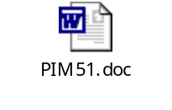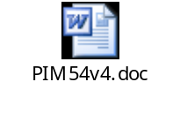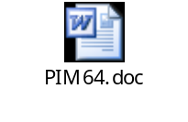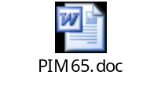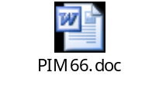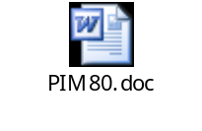
- Large Port Notification Best Practice – Sue Tiffany, Sprint Nextel

Action Item 011111-10: Sue Tiffany, Sprint Nextel, will draft a proposed Best Practice on Service Provider notification to NPAC for large port projects. This will be reviewed and discussed at the March 2011 LNPA WG meeting.
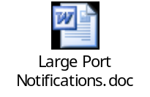

- LTI Enhancements Update – Lavinia Rotaru, Neustar

- Scheduling of Release 3.4 Performance Testing – All

11:30 – 1:00 - Lunch

1:00 p.m. - Continuation of Morning Agenda (IF NECESSARY) – All

LNPA Working Group Meeting Schedule
March 15-16, 2011
Hosted by Comcast
5800 S. Quebec St.
Greenwood Village, CO 80111.

Agenda

LNPA Working Group (LNPA WG) - CONTINUED

Wednesday, March 16, 2011 9:00 AM – 5:00 PM (Mountain Time Zone)

Conference Bridge – 888-412-7808 PIN 23272#

- Change Management – Neustar
(Any Change Management documents will be distributed separately.)

Action Item 020811-03: Renee Dillon, AT&T Mobility, will propose a revision to the NANC 397 engineering assumption for Service Providers to clarify that the requirement is to support the SOA and LSMS throughput requirements in NANC 397 for each association in every NPAC Region a Service Provider is connected. It will also clarify that the requirement is propagated down to the Network Element, meaning that it is a throughput requirement from NPAC down to the Network Element. This will be discussed and finalized at the March 2011 LNPA WG meeting.

Proposed Revision to NANC 397 Assumption Text:
NANC 397 increases the performance requirements for each NPAC region from 4 transactions per second per Service Provider to 7 transactions per second per Service Provider.

The 397 requirement is for the NPAC vendor.

“Any region” assumption:
There is an implied engineering assumption; NPAC vendor must support the new performance requirements for NANC 397 for each NPAC region, i.e. 7 transactions per second per service provider.

This equates to a possibility of 7 transactions per second per Service Provider for each of the 7 regions (specific to U.S. NPAC region performance).

Service Provider assumption:
There is an implied engineering assumption; Service Providers must support the new performance requirements for NANC 397. The Service Provider's local systems must support up to the maximum throughput rate with all of a Service Provider's specific associations to NPAC regions, based on the requirements of NANC 397.
LNPA Working Group Meeting Schedule
March 15-16, 2011
Hosted by Comcast
5800 S. Quebec St.
Greenwood Village, CO 80111.

Agenda

LNPA Working Group (LNPA WG) - CONTINUED

Wednesday, March 16, 2011 9:00 AM – 5:00 PM (Mountain Time Zone)

Conference Bridge – 888-412-7808 PIN 23272#

As Service Providers are responsible for their local systems that support their interfaces to the NPAC (aka SOA, LSMS and corresponding downstream network elements), each Service Provider should work with their local system vendors to ensure that their (the Service Provider) interface solution will adequately support the same industry requirements to the NPAC without impact to other Service Providers in the industry.

It is recommended that each Service Provider spend time working performance requirements with their local system vendors as well as the NPAC vendor.

- Update on Issue Related to Sale of Vanity Numbers – Lonnie Keck,
AT&T Mobility

Action Item 081010-02: Regarding the issue raised during the New Business portion of the August 10, 2010 LNPA WG conference call related to the sale and sometime fraudulent porting of vanity numbers, Lonnie Keck, AT&T Mobility, along with Deb Tucker, Verizon Wireless, Sue Tiffany, Sprint Nextel, Tina Plaisance, Alltel/Verizon Wireless, and Mohamed Samater, T-Mobile, will write up a description of the issue for review at the September 14-15, 2010 LNPA WG meeting. This issue will be presented at the next NANC meeting. See related Action Item 081010-06.
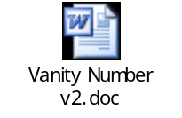

- Begin Review of the NANC Guidelines & Operating Principles and
NANC Operating Manual (Training Binder) – All

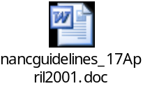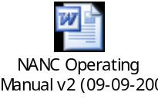

LNPA Working Group Meeting Schedule
March 15-16, 2011
Hosted by Comcast
5800 S. Quebec St.
Greenwood Village, CO 80111.

Agenda

LNPA Working Group (LNPA WG) - CONTINUED

Wednesday, March 16, 2011 9:00 AM – 5:00 PM (Mountain Time Zone)

Conference Bridge – 888-412-7808 PIN 23272#

- 2011 LNPA WG Meeting/Call Schedule – All
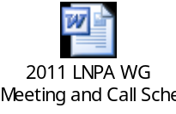

- Discussion of Need for April 12, 2011 LNPA WG Call – All

- Action Items Not Previously Discussed in Agenda – All

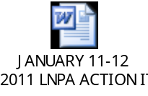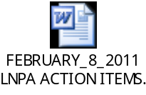

- Unfinished/New Business – All

- Proposed Best Practice on CSRs – Gary Sacra, Verizon
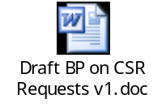
- Proposed Best Practice on SCRA – Gary Sacra, Verizon
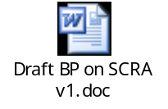

5:00 p.m. - Adjourn

Next LNPA WG APT Live Meeting Call … April 12, 2011, from 11am to 2pm Eastern: Dial-in Bridge 888-412-7808, pin 23272#.

Next LNPA WG Conference Call … April 12, 2011 (If Necessary)

Next Meeting …May 10-11, 2011: Location…Banff, Canada…Hosted by Canadian LNP Consortium

